**NAME OF SCHOOL: ................................................................................**

**NAME OF CANDIDATE: ..........................................................................**

**INDEX NO: ..................................... SIGNATURE: ................................**

**535/2**

**PHYSICS**

**PAPER 2**

**JULY/AUGUST**

**2 ¼ HOURS**



**ELITE EXAMINATION BUREAU MOCK 2019**

**Uganda Certificate of Education**

**PHYSICS**

**PAPER 2**

2 HOURS 15 MINUTES

**INSTRUCTIONS TO CANDIDATES:**

* *Attempt any five questions.*
* *Mathematical tables and non – programmable calculators may be used.*
* *These values of physical quantities may be useful to you.*
* Acceleration due to gravity = 10ms-2
* Specific heat capacity of water = 4200Jkg-1k-1
* specific heat capacity of copper = 400JKg-1K-1
* specific latent heat of fusion of water = 340000Jkg-1
* speed of sound in air = 320ms-1
* velocity of electromagnetic waves = 3.0 x 108ms-1
* density of water = 1000Kgm-3

1. a) i) Distinguish between a scalar and a vector. (2 marks)

ii) Write at least two examples of each of the quantities above.

(2 marks)

iii) Two vectors 3N and 4N act at right angles on an object of mass 2kg. Calculate the resultant force and acceleration of the object.

(4 marks)

b) i) What is meant by acceleration due to gravity? (1 mark)

ii) Describe an experiment to determine the acceleration due to gravity. (5 marks)

iii) A 5kgs mass is dropped from a height above the ground and hits the ground after 4.5s. Calculate the height of the body from the ground. (2 marks)

2. a) Define the following terms;

i) Mechanical advantage. (1 mark)

ii) Velocity ratio. (1 mark)

b) Figure 1 below shows a wheel and axle used to raise water from a well.

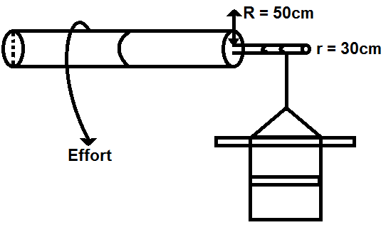**Figure 1.**

**R = 60cm**

i) If the system is 75% efficient, calculate effort needed to raise water of mass 100Kg. (6 marks)

ii) Sketch a graph of mechanical advantage with load for a pulley system. (2 marks)

iii) Name two practical applications of the block and tackle pulley system. (2 marks)

iv) Explain briefly why the efficiency of the machines is less than 100%. (2 marks)

3. a) Define pressure and state its units. (2 marks)

b) A block of concrete of mass 50kg and dimensions 0.3m x 1.5m x 0.1m rests on a bench. Calculate,

i) The least pressure. (4 marks)

ii) State two factors that affect pressure in solids. (2 marks)

c) i) Describe briefly the action of a common pump. What is its limitation? (6 marks)

ii) State the principle of transmission of pressure. (1 mark)

iii) State two applications of this principle. (1 mark)

iv) Explain why the pump cylinder of a hydraulic press has a small area compared to the ram cylinder. (2 marks)

4. a) i) State the principle of conservation of energy. (1 mark)

ii) Illustrate the principle in (a) (i) with reference to a simple pendulum in a vacuum. (4 marks)

b) A ball of mass 0.30kg falls from rest at a height of 4.0m onto a horizontal surface and rebounds to a height of 2.0cm.

i) Find the kinetic energy just before the ball hits the surface and just after collision. Explain the difference between the two energies. (5 marks)

ii) State the energy changes that take place in b(i) above. (2 marks)

5. a) Explain what is meant by dispersion of light. (2 marks)

b) With the aid of a diagram, describe an experiment to produce a pure spectrum. (5 marks)

c) Light of same wave length is incident at an angle, **i**, on a glass prism. The light is refracted and follows the path shown in figure 2 below.

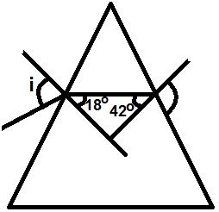**Figure 2.**

Find the angle of incidence, **i** if the refractive index of the glass material is 1.5. (5 marks)

d) i) Draw diagrams to show how critical angle and total internal reflection occurs. (3 marks)

ii) Find critical angle for water whose refractive index is 1.33.

(2 marks)

6. a) Define the term constructive interference as applied to sound waves.

(1 mark)

b) The figure 3 below shows a source of sound behind a barrier with a single hole, **h**, placed behind another barrier with two identical holes **h1** and **h2**. A sound detector is moved along a line PQ.

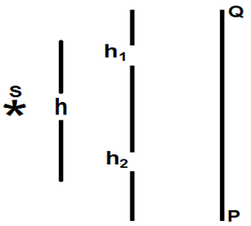 **Figure 3.**

i) With the aid of a diagram explain what is detected. (4 marks)

ii) What is the significance of **h1** and **h2**? (2 marks)

c) Describe an experiment to show that sound require a material medium for transmission. (4 marks)

d) A sound of frequency 250Hz is produced 120m away from a high wall. Calculate:

i) Wave length. (2 marks)

ii) Time it takes the sound wave to travel to and from the wall.

(Speed of sound in air = 330ms**-1**) (3 marks)

7. a) Define the following terms:

i) A volt (1 mark)

ii) Electrical resistance. (1 mark)

b) A battery of e.m.f 2.0V and negligible internal resistance is connected as shown in the figure 4 below.

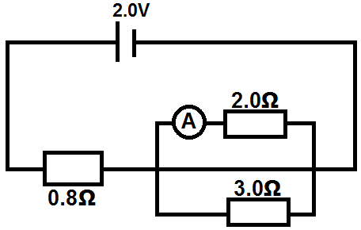**Figure 4.**

Find the reading of the ammeter. (5 marks)

c) i) Give the advantages of alternating current over direct current in power transmission. (2 marks)

ii) Describe with the aid of a diagram, the construction and action of a transformer. (4 marks)

iii) State three possible causes of power losses in a transformer.

(3 marks)

8. a) What are X – rays? (1 mark)

b) With the aid of a labelled diagram describe the structure and operation of an X – ray tube. (5 marks)

c) i) Define the terms radioisotope and half-life. (2 marks)

ii) An isotope carbon – 14  decays by emitting a beta particle to yield nitrogen. Represent this process using a nuclear equation.

(2 marks)

d) A nuclide of radium has half-life of 1622 years. Calculate the time taken for a sample of radium to decay to ⅛ of the original amount.

(3 marks)

e) State any two properties of Beta radiations. (2 marks)

**END**